PHÉP CO VÀ DÃN ẢNH – Bài 2

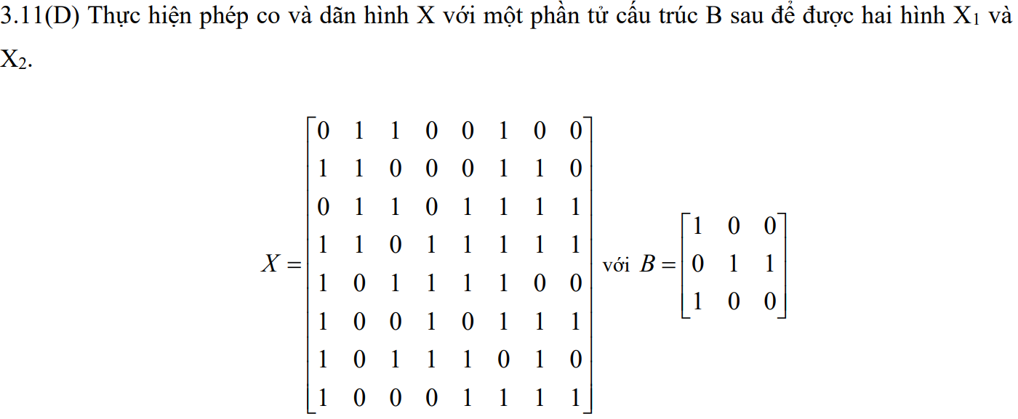

ĐÁP ÁN

|  |  |  |  |  |  |  |  |  |  |  |  |  |  |  |  |  |  |  |  |  |  |  |  |  |  |  |  |  |  |  |  |  |  |  |  |  |  |  |  |  |  |  |  |  |  |  |  |  |  |  |  |  |  |  |  |  |  |  |  |  |  |  |  |  |  |  |  |  |  |  |  |  |  |  |  |  |  |  |  |  |  |  |  |  |  |  |  |  |  |  |  |  |  |  |  |  |  |  |  |  |  |  |  |  |  |  |  |  |  |  |  |  |  |  |  |  |  |  |  |  |  |  |  |  |  |  |  |  |  |
| --- | --- | --- | --- | --- | --- | --- | --- | --- | --- | --- | --- | --- | --- | --- | --- | --- | --- | --- | --- | --- | --- | --- | --- | --- | --- | --- | --- | --- | --- | --- | --- | --- | --- | --- | --- | --- | --- | --- | --- | --- | --- | --- | --- | --- | --- | --- | --- | --- | --- | --- | --- | --- | --- | --- | --- | --- | --- | --- | --- | --- | --- | --- | --- | --- | --- | --- | --- | --- | --- | --- | --- | --- | --- | --- | --- | --- | --- | --- | --- | --- | --- | --- | --- | --- | --- | --- | --- | --- | --- | --- | --- | --- | --- | --- | --- | --- | --- | --- | --- | --- | --- | --- | --- | --- | --- | --- | --- | --- | --- | --- | --- | --- | --- | --- | --- | --- | --- | --- | --- | --- | --- | --- | --- | --- | --- | --- | --- | --- | --- |
| Ảnh co   |  |  |  |  |  |  |  |  | | --- | --- | --- | --- | --- | --- | --- | --- | | 0 | 0 | 0 | 0 | 0 | 0 | 0 | 0 | | 0 | 0 | 0 | 0 | 0 | 0 | 0 | 0 | | 0 | **1** | 0 | 0 | 0 | 0 | **1** | 0 | | 0 | 0 | 0 | **1** | 0 | **1** | **1** | 0 | | 0 | 0 | 0 | 0 | **1** | 0 | 0 | 0 | | 0 | 0 | 0 | 0 | 0 | **1** | 0 | 0 | | 0 | 0 | 0 | 0 | 0 | 0 | 0 | 0 | | 0 | 0 | 0 | 0 | 0 | 0 | 0 | 0 | | Ảnh giãn   |  |  |  |  |  |  |  |  | | --- | --- | --- | --- | --- | --- | --- | --- | | 1 | 1 | 1 | **0** | 1 | 1 | 1 | 1 | | 1 | 1 | 1 | 1 | 1 | 1 | 1 | 1 | | 1 | 1 | 1 | 1 | 1 | 1 | 1 | 1 | | 1 | 1 | 1 | 1 | 1 | 1 | 1 | 1 | | 1 | 1 | 1 | 1 | 1 | 1 | 1 | 1 | | 1 | 1 | 1 | 1 | 1 | 1 | 1 | 1 | | 1 | 1 | 1 | 1 | 1 | 1 | 1 | 1 | | 1 | 1 | **0** | 1 | 1 | 1 | 1 | 1 | |